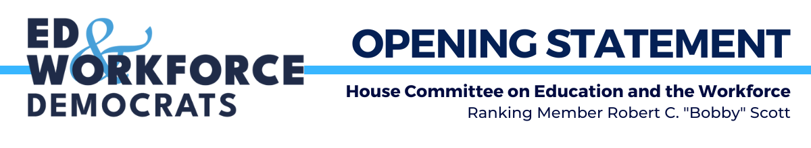Opening Statement of Ranking Member Scott (VA-03)
Full Committee Hearing
Examining the Policies and Priorities of the U.S. Department of Health and Human Services
2175 RHOB
Tuesday, June 13, 2023 | 10:15 a.m.

Thank you, Dr. Foxx.

Secretary Becerra, good morning and thank you for being with us today. It is always a pleasure to welcome you back to the Committee.

You are familiar with this room. You and I began our congressional careers in this room 30 years ago, and it is a pleasure to see you back. It is also a pleasure to see you discuss your work to protect our nation’s well-being.

One of the enduring lessons reaffirmed during the COVID-19 pandemic is that, when we invest in the health of our communities, we provide people with the tools and resources to care for themselves and their loves ones.

Under your leadership, the Department of Health and Human Services has made historic investments to help every worker and family get quality, affordable care.

Last Congress, we passed the American Rescue Plan Act, which you had a lot to do with. It enhanced premium tax credits to lower monthly costs for low-income Americans, especially by eliminating the subsidy “cliff” so that more individuals could get coverage.

We also passed the Inflation Reduction Act to extend these tax credit enhancements, cap the cost of insulin for people with Medicare, and—for the first time ever—direct the federal government to negotiate lower prices for prescription drugs covered by Medicare.

These decisive actions have yielded results. Last August, we brought the portion of Americans without health insurance down to the lowest level ever. During the most recent Open Enrollment Period, a record 16.3 million people signed up for Marketplace coverage.

We also know that protecting our nation’s health goes beyond improving access to health insurance.

That is why, last Congress, we also secured House passage of legislation to prevent child abuse, address domestic violence, and lift people out of poverty.

Unfortunately, while my colleagues on the other side speak frequently about their commitment to our nation’s health and safety, they have not backed up their words with actions.

For example, my Republican colleagues may talk about child labor today. However, the reality is that they sought to hold our nation’s full faith and credit hostage and threatened severe cuts to federal resources that protect children and can prevent these abuses from happening. Republican state legislators all over the country are working to reverse child worker protection laws. And, despite our letter requesting a hearing on this persistent and growing problem, the Majority has yet to schedule a hearing or advance legislation to address child labor violations.

Instead, we have seen Republican politicians continue to attempt to sabotage quality health care coverage and undermine access to services that our constituents need.

The nation is witnessing the harsh restrictions and criminalization of women’s access to abortions, jeopardizing the health of women and families across the country.

We are all bearing witness to the baseless villainization of the necessary care that supports transgender individuals. And you heard some of that just a moment ago.

Earlier this year, a federal judge in the 5th Circuit—who previously tried to eliminate the Affordable Care Act before it was upheld by the Supreme Court—ruled to strip millions of Americans of access to preventive care. And, thankfully, that ruling has been temporarily suspended.

Just last week, the Committee Majority voted to report out two bills that increase health care costs for vulnerable Americans by expanding association health plans and blocking state and federal consumer protections for stop loss insurance.

In contrast, Congressional Democrats and this administration will continue working to lower prescription drug prices, strengthen the ACA, and improve transparency for health care consumers.

Committee Democrats remain focused on how this administration can help build on our progress to:
- Ensure equal access to care for our most vulnerable communities,
- Meet the changing health care needs of families, and,
- Lower the cost of quality health care and community support.

The Administration’s proposed investments underscore your commitment to protecting the health and well-being of every American.

So, thank you, Secretary Becerra, for all your work and for joining us today. I look forward to our discussion.

